**Network Task**

**1.Get me the IP address of a particular domain (guvi.in). How do I find my CPU/memory usage of my server?. Test the connectivity between 2 nodes?**

* Ipaddress = **nslookup guvi.in**
* CPU/memory usage = **top**
* Connectivity = **curl -v** [**https://google.com:80**](https://google.com:80) , **ping <hostname of second node>**

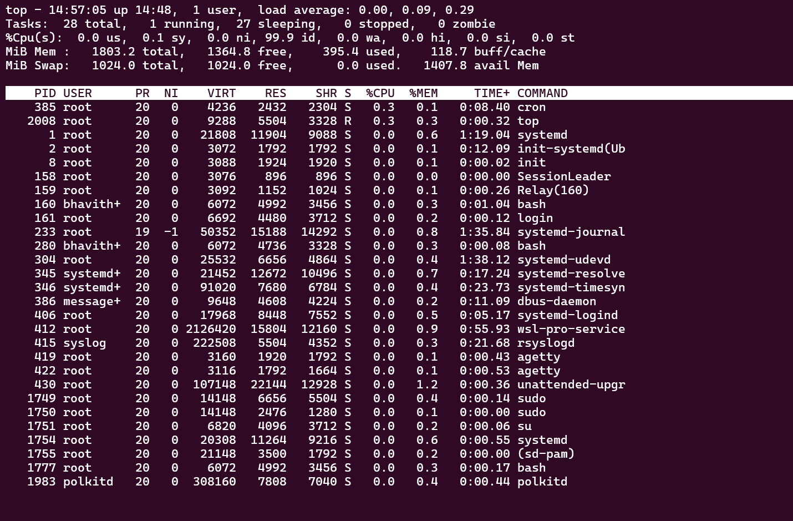

**2.I have deployed an application in guvi.com:9000, and logs show my app is running, but I’m unable to view the page. Check whether my port is open or not ?**

* **telnet guvi.com 9000**
* **curl -I http://guvi.com:9000**